EXP NO:01

1. AIM
To develop a Python program to represent the grade distribution of 40 students using a pie chart and a bar chart, identify the maximum and minimum student counts, and calculate the combined percentage of students who secured grades A and S.
2. PROCEDURE

- Import the matplotlib. pyplot library.
- Store the grades and corresponding number of students in lists.
- Calculate the total number of students and the percentage for each grade.
- Draw a pie chart to represent the percentage distribution of students across all seven grades.
- Display grade labels and percentage values on the pie chart and add a suitable title and legend.
- Draw a bar chart to compare the number of students in each grade.
- Label the X-axis as Grades and the Y-axis as Number of Students.
- Display the exact number of students above each bar.
- Identify the grades with the maximum and minimum numbers of students.
- Calculate and display the combined percentage of students who secured grades A and S.
- Execute the program and observe the charts and output.

3. CODE:

import matplotlib.pyplot as plt

# 1. Store grades and number of students
grades = ['F', 'E', 'D', 'C', 'B', 'A', 'S']
students = [3, 4, 5, 8, 9, 7, 4]

total_students = sum(students)

# 2. Calculate percentage distribution
percentages = [(n / total_students) * 100 for n in students]

# 3. Draw Pie Chart
plt.figure(figsize=(8, 6))

plt.pie(
students,
labels=grades,
autopct='%1.1f%%',
startangle=90
)

plt.title('Percentage Distribution of Students by Grade')
plt.legend(grades, title='Grades', loc='best')
plt.show()

# 4. Draw Bar Chart
plt.figure(figsize=(8, 6))

bars = plt.bar(grades, students)

# 5. Label X-axis and Y-axis
plt.xlabel('Grades')
plt.ylabel('Number of Students')
plt.title('Number of Students in Each Grade')

# 6. Display exact number above each bar
for bar in bars:
height = bar.get_height()
plt.text(
bar.get_x() + bar.get_width() / 2,
height,
str(int(height)),
ha='center',
va='bottom'
)

plt.legend(['Students'])
plt.show()

# 7. Identify maximum and minimum grades
max_students = max(students)
min_students = min(students)

max_grades = [
grades[i] for i in range(len(grades))
if students[i] == max_students
]

min_grades = [
grades[i] for i in range(len(grades))
if students[i] == min_students
]

print("Total number of students:", total_students)
print("Maximum students:", max_students, "Grade:", max_grades)
print("Minimum students:", min_students, "Grade:", min_grades)

# 8. Calculate combined percentage of A and S
a_s_students = students[grades.index('A')] + students[grades.index('S')]
a_s_percentage = (a_s_students / total_students) * 100

print("Students with grades A and S combined:", a_s_students)
print("Percentage of students with grades A and S:",
round(a_s_percentage, 2), "%")

4.OUTPUT:
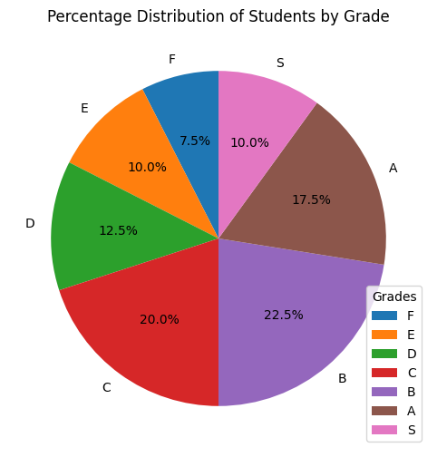
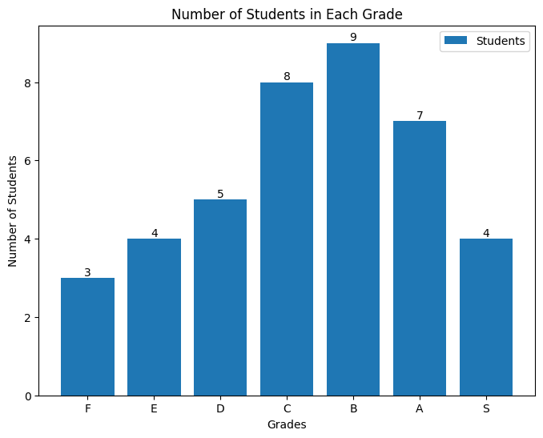
Total number of students: 40
Maximum students: 9 Grade: ['B']
Minimum students: 3 Grade: ['F']
Students with grades A and S combined: 11
Percentage of students with grades A and S: 27.5 %
5.RESULT:
The Python program was executed successfully. The pie chart displayed the percentage distribution of students across the seven grades, and the bar chart compared the number of students in each grade.
- Maximum number of students: Grade B — 9 students.
- Minimum number of students: Grade F — 3 students.
- Students who secured grades A and S combined: 11 students.
- Combined percentage of grades A and S: 27.5%.
Thus, the program successfully generated both charts and displayed the required statistical results.
EXP NO:02

1. AIM
To represent concepts and their labelled relationships as a directed semantic network using Python and the Network library.
2. PROCEDURE
- Install the Network library using pip install network.
- Import the NetworkX library.
- Create a directed graph using nx.DiGraph().
- Add concepts and their relationships as edges in the graph.
- Assign relationship labels such as is-a and has-instance.
- Display each relationship using a for loop.
- Execute the program and observe the output.
3. PROGRAM

import networkx as nx

# Create a directed graph
G = nx.DiGraph()

# Add concepts and labeled relationships
G.add_edge("Dog", "Mammal", relation="is-a")
G.add_edge("Mammal", "Animal", relation="is-a")
G.add_edge("Dog", "Tommy", relation="has-instance")

# Display relationships
print("Semantic Network Relationships:")

for source, target, data in G.edges(data=True):
print(source, "--", data["relation"], "-->", target)

4. EXPECTED OUTPUT

Semantic Network Relationships:
Dog -- is-a --> Mammal
Dog -- has-instance --> Tommy
Mammal -- is-a --> Animal

5. RESULT
The Python program was executed successfully using NetworkX. The directed semantic network represented concepts such as Dog, Mammal, Animal, and Tommy, along with their labelled relationships (is-a and has-instance).

EXP NO:03

1. AIM
To represent an object using frame-based knowledge representation in Python by storing its attributes as slots and their corresponding values.

2. PROCEDURE
- Open Python IDLE or any Python editor.
- Create a dictionary named vehicle.
- Define the slots as keys, such as class, brand, fuel type, wheels, and color.
- Assign appropriate values to each slot.
- Display the frame title using the print() function.
- Use a for loop with the items() method to display each slot and its value.
- Execute the program and observe the output.

3. PROGRAM
vehicle = {
"class": "Vehicle",
"brand": "Toyota",
"fuel_type": "Petrol",
"wheels": 4,
"color": "White"
}

# Display the frame
print("Vehicle Frame")

for slot, value in vehicle.items():
print(slot, ":", value)

4. EXPECTED OUTPUT
Vehicle Frame
class : Vehicle
brand : Toyota
fuel_type : Petrol
wheels : 4
color : White

5. RESULT
The Python program was executed successfully. The vehicle was represented using a dictionary, where each key represents a slot and each value represents the corresponding attribute of the vehicle.

